

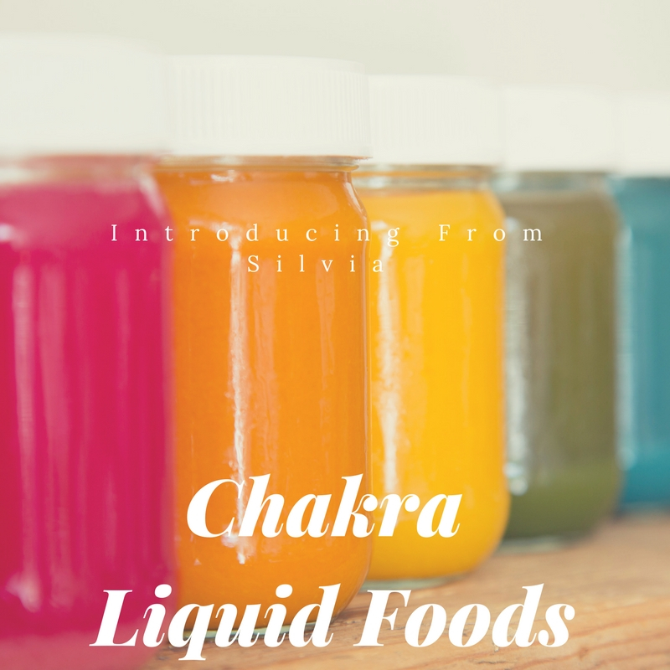

**2018 - From Silvia Chakra Liquid Food**

From Silvia strives to continue to set the Benchmark for Tomorrow's Food and is delighted to Introduce our latest Liquid Food with Plant Based Protein Option - suitable for most with Special Dietary Needs

As with all our offerings, this latest addition to our range was a response to our customers with their dietary needs wanting

* Gut Cleansing/Fasting Support Options
* Plant Based Vegetarian/Fruit Shots
* Healthy Booster Options
* Nutritional 'On The Move' Options

*without*commercial compounds and bases.

The Purity of OUR LIQUID FOOD (LF)  is cold pressed to ensure highest integrity of nutrients with an extended chill life of up to 21 days:

Energising Red - is the LF for overall energy boosting, helps keep tummies happy as it aids in digestion & circulation and can help soothe cramps. Is rich in vitamins.

Key ingredients are: Apple, Ginger, Lemon & Dragon fruit

Love Me Orange - is ideal to support gut health & for managing fatigue. In Traditional Chinese Medicine (TCM) & Ayurveda some of the key ingredients in this LF are considered stimulating to the "digestive fire' with high detoxifying properties, rich in antioxidants, dietary fibres, minerals and vitamins A, B, C, K.

Key Ingredients are: Mandarin, Carrot, Peach, and Turmeric & Ginseng

Mindful Yellow - is LF Nutrition 'On the Move'. Rich in Nature's vitamins & minerals including thiamine and manganese, its key ingredients play a major role in Immune Health, Bone Strength, Eye Health, Energy Production and Digestion. Its taste is of natural sweetness, it's low in calories and an ideal LF for those prone to asthma.

Key Ingredients are: Mandarin, Pineapple, Passionfruit, and Lemon & Lime.

Chill Green - is the perfect food when you don't have time to stop or know you should have a meal but don't! Additional benefits of this LF are; its low in fats and cholesterol, high in the essential vitamins & minerals, both the kiwi & mint are nature's helper in digestion and stress management and the parsley helps relief bloating & is same time full of natural antibacterial & anti fungal properties. And it tastes so yummy :)

Key Ingredients are: Apple, Spinach, Kale, Celery, Cucumber, Kiwi, Mint and Parsley.

True Blue - is the FUN plant based protein LF. The Blue Spirulina provides the Plan Based Protein (PBP), much needed in a Vegetarian or vegan diet. Same time anyone who is active benefits from the PBP. Pineapple is added for its properties that aid our Immune System, Eye Health, Bone Strength and Digestion. Apple contributes much needed phytonutrients, important antioxidants and dietary fibre for overall health management and the lemon assists our body to absorb iron, fight off many of modern day diseases and of course a major source of Vit C.

Key Ingredients are: Apple, Pineapple, and Lemon & Blue Spirulina.

Peaceful Purple - packed with antioxidants, immune boosting Vit C and minerals such as potassium (essential for healthy nerves & muscle function) and manganese ( good for bones, liver, kidney & pancreas), this LF is all about Health Restore; can help lower blood pressure, is a stamina booster, contributes to fighting inflammation, contains powerful phytonutrients that have anti cancer properties, are rich in valuable nutrients and fibre, provides detoxification support.

Key Ingredients are: Beetroot, Carrot, Mandarin, Ginger, and Blackberry & Lime.